Changing East/West Gateway
For Cisco Secure AnyConnect

- Launch CISCO AnyConnect. using the Start menu or Desktop Icon on your PC.

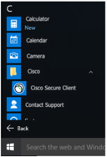

- Input qies-west.cms.gov or qies-east.cms.gov, then click “CONNECT”.

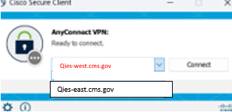

NOTE: Facilities WEST of the Mississippi River will use QIES-WEST Facilities EAST of the Mississippi River will use QIES-EAST This is strictly for load balancing. It will not affect your submission. If the West is down, you can use the East and vice versa.
- Click “Connect.”
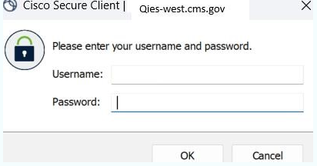
- Enter Your CMSNet Username and Password and press ok. (Usually the one beginning with a “C” followed by 6 numbers.)

